EXPERIMENT 6 C

DATA VISUALIZATION USING POWER BI

Aim
To import, transform, analyze, and visualize the patient dataset using Power BI Desktop and create an interactive dashboard.

Algorithm 1 – Importing Data into Power BI
Step 1 Open Power BI Desktop.
Step 2 Select Home → Get Data → Text/CSV.
Step 3 Browse your dataset.
Step 4 Click Load.
Step 5 Verify the imported data.

Output

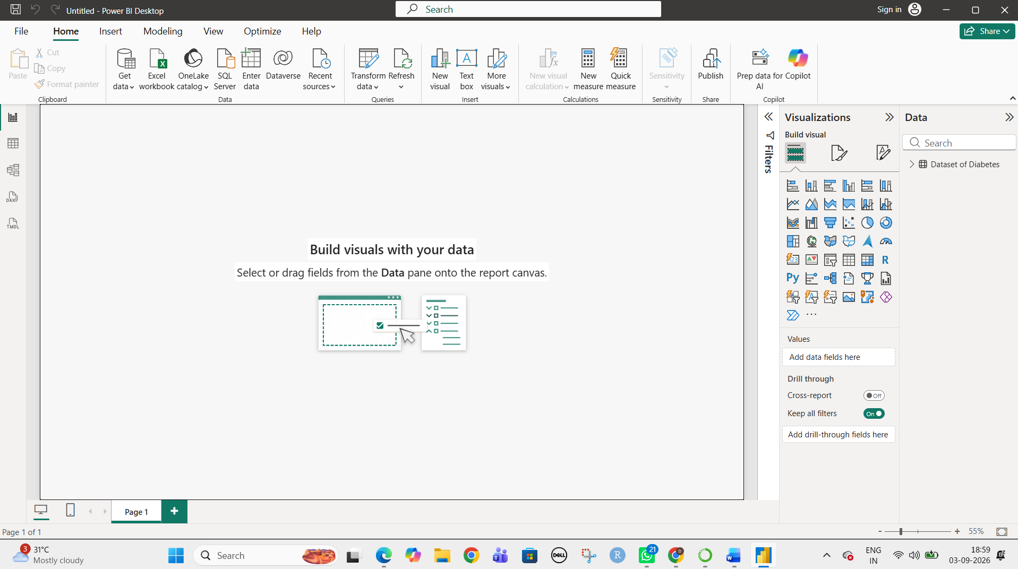

Algorithm 2 – Data Transformation
Step 1 Select Transform Data.
Step 2 Open Power Query Editor.
Step 3 Remove duplicate records.
Step 4 Handle missing values.
Step 5 Check data types.
Step 6 Click Close & Apply.

Output

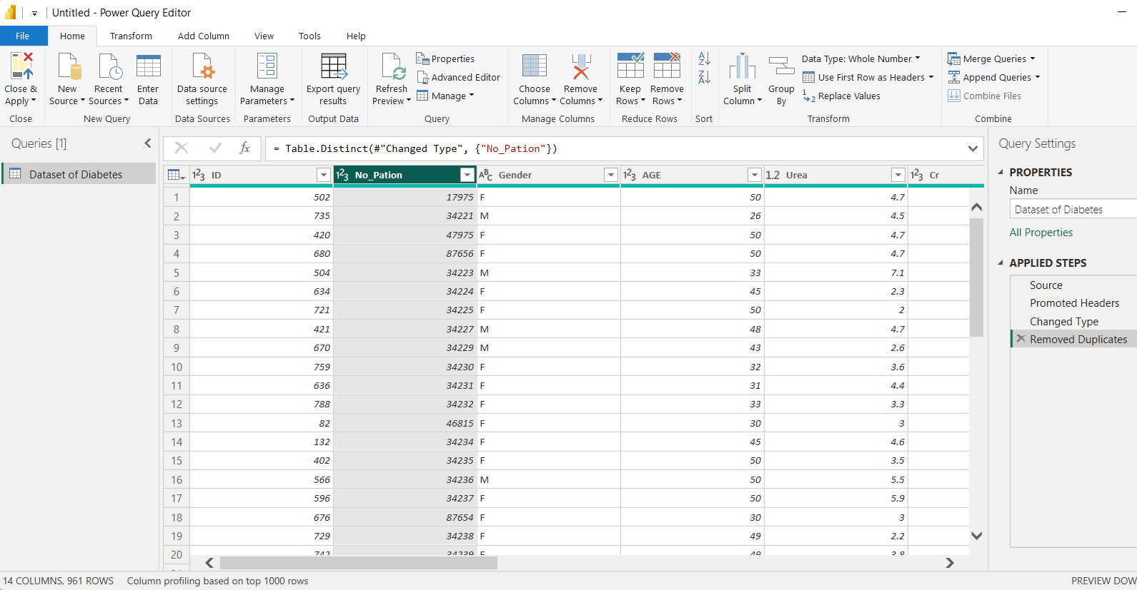

Algorithm 3 – Creating a Bar Chart
Step 1 Select Bar Chart.
Step 2 Drag Gender → Axis.
Step 3 Drag AGE → Values.
Step 4 Apply formatting.

Output
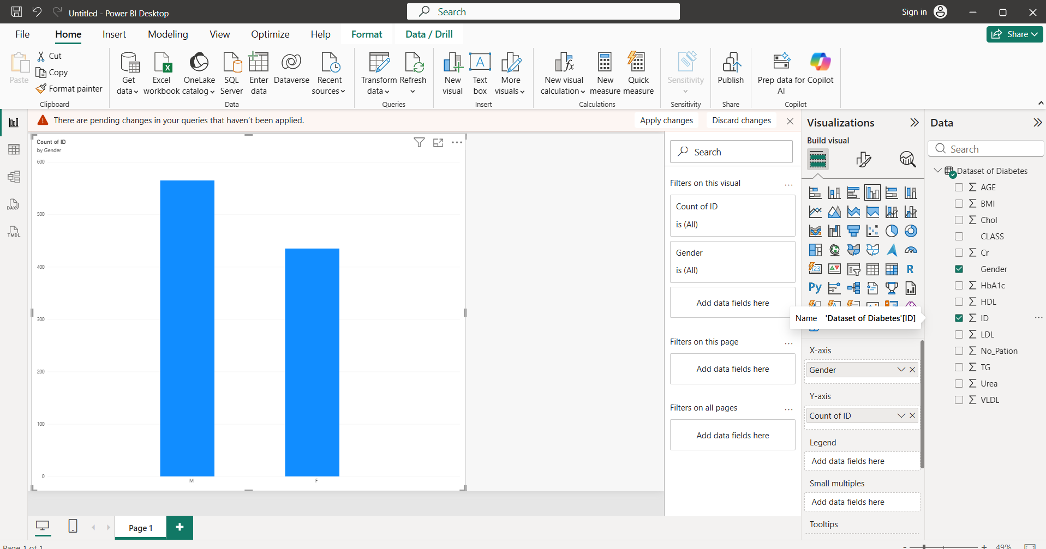

Algorithm 4 – Creating a Pie Chart
Step 1 Select Pie Chart.
Step 2 Drag CLASS → Legend.
Step 3 Drag ID → Values.
Step 4 Enable data labels.

Output
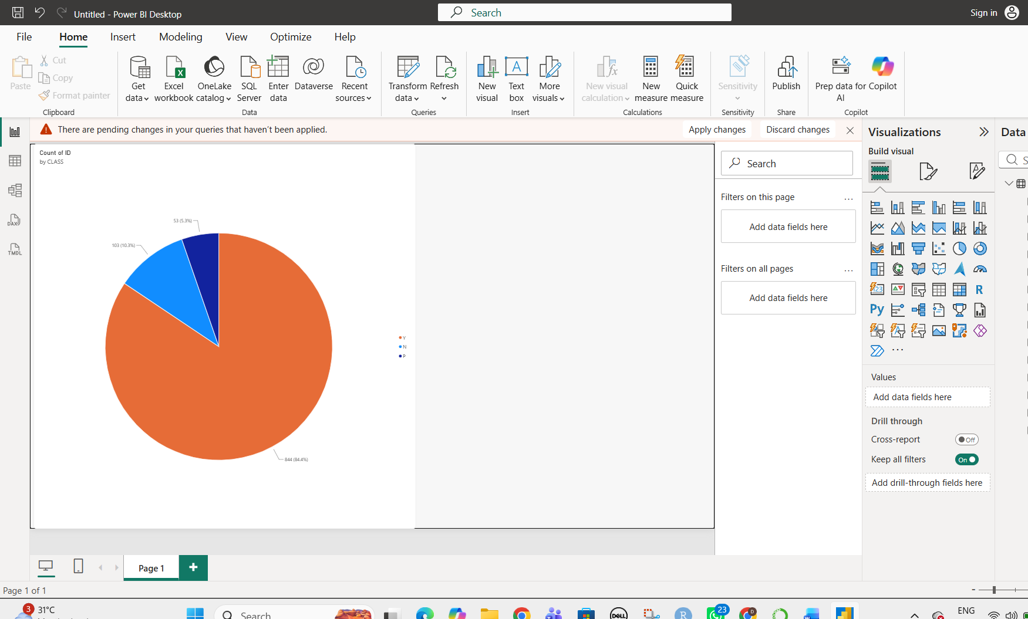

Algorithm 5 – Creating a KPI Card
Step 1 Select Card visualization.
Step 2 Drag AGE to Values.
Step 3 Set aggregation as Average.

Output

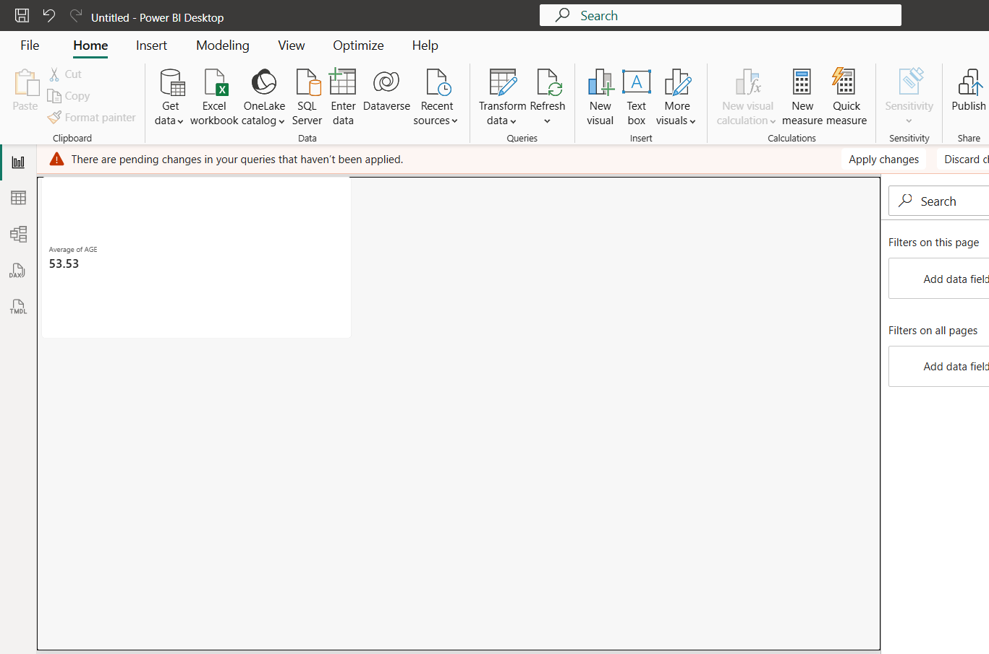

Algorithm 6 – Creating Slicers
Step 1 Select Slicer visualization.
Step 2 Drag Gender field.
Step 3 Select a gender value.
Step 4 Apply the filter.

Output

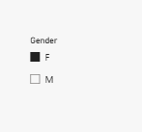

Algorithm 8
Step 1 Add KPI Card.
Step 2 Add Bar Chart.
Step 3 Add Pie Chart.
Step 4 Add Slicer.
Step 5 Arrange the visuals.
Step 6 Save the dashboard.

Result
Thus, the patient dataset was successfully imported, transformed, analyzed, and visualized in Power BI using charts, KPI cards, slicers, DAX measures, and an interactive dashboard.

